Chapter 4

Covalent compounds are formed by the ____________________ of _______________________. A covalent bond forms between _____ _________-_____________________. They will share electrons because non-metals have ____________ ____________________ electrons, meaning all need extra electrons to achieve a stable electron configuration and none will want to give up any of their electrons.

Covalent bonding can be described as the ________________________ attraction between the __________________ ____________________ and the ___________________ _____________________ ___________________.

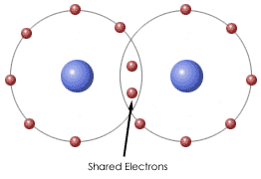
e.g

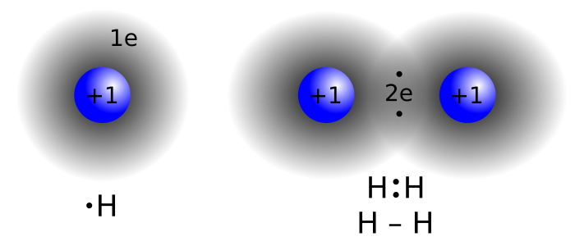

A _________________ covalent bond consists of ______ shared electrons.
e.g.

A ________________ covalent bonds consists of ______ shared electrons.
e.g.

A _________________ covalent bond consists of ______ shared electrons.
e.g.
In each case, the aim of the bonding is still to achieve a _________________ ___________________ _________________________ which usually involves an outer shell of _______.

Draw electron dot diagrams for the following covalent substances.

Neon | Water | Ammonia
Methane | Sulfur dichloride | Fluorine
Sulfur dioxide | Phosphorus trihydride | Methanol (CH₃OH)
Hydrogen cyanide | Methanal (CH₂O) | Carbon dioxide

Covalent Molecular Substances

Most substances that exist in the world are covalent molecular substances. This means they are composed of only ________-________________ elements and exist as _________________ ___________________. These molecules do not have any _______________, nor do they contain particles within them that are charged.

The covalent bonds which hold the individual molecules together are referred to as _________________________________ bonds and these are ____________ __________________.
e.g.

The bonds that hold a group of covalent molecules together in a solid or liquid state are referred to as _________________________________ bonds are these are _____________ in comparison. This is why many covalent molecular substances are ________________ or _________________ at room temperature, and if they are solids they are _______________ and _______________.

Low melting and boiling point
In a covalent molecular substance the individual molecules of the substance are held together by _____________ ________________________________ forces.
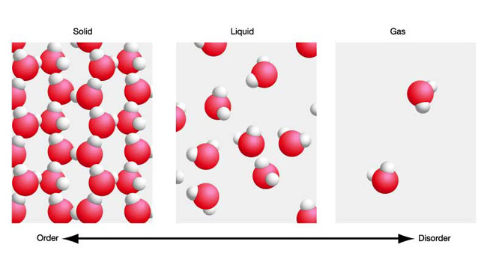
Since these forces are easy to ________________ only a ______________ amount of heat is required to melt or boil a covalent molecular substance. Many are liquids and gases at room temperature meaning that their melting and/or boiling points must be below about 25 ⁰C. Covalent molecular solids (e.g. candle wax, butter, sugar) are composed of ____________________ molecules and have higher melting and boiling points but these are still very low when compared with metallic and ionic substances.
Soft
This is also due to the weak _____________________________ forces. In covalent molecular solids such as butter, chocolate and candle wax it does not require much _______________ to move the molecules past one another. Note that again, this does not require the actual covalent bonds to be broken.

Malleable
Once again, because of the weak intermolecular forces, the molecules of a covalent molecular solid can be __________________ past one another easily if a _________________ is applied. This can be seen easily with substances like _________________, ___________ and __________________. Once the ______________ of the solid has been changed, the weak intermolecular forces still ________________ and hold the substance together.

Non-conductors of electricity
Covalent molecular substances ______________ conduct electricity in any state. This is because they do not contain any mobile charge. They contain no __________ and their __________________ are ____________________ around the molecule either in a bonding or non-bonding pair, leaving nothing to act as a carrier of current.

However, some covalent substances are capable of conducting electricity once they are dissolved in water e.g. _____________________________________________________________________
This can happen if the covalent molecules are able to ____________________, which means that they react with the water to form __________. These ions are then able to carry an electric current. It is generally molecules such as acids that are able to do this.

Strong acids such as HCl, H₂SO₄ and HNO₃ __________________ ionise in water, existing 100% as ions. These are very good conductors of electricity e.g. ___________________________________.
Weak acids such as CH₃COOH ____________________ ionise in water, with only a small % existing as ions. These are weak conductors of electricity e.g. ______________________________________.
Many covalent molecular substances will not react to form ions in water and will therefore not be able to conduct electricity e.g. __________________________________________.

Solubility
The solubility of covalent molecular substances in different solvents ________________ greatly.
Formulae and Names of Covalent Compound
Since the same non-metals can bond with each other in a variety of ways, the formulae and naming of covalent compounds differs from ionic.
e.g. _________________________________________________________________________
As with all formulae, they show the number of each type of atom in the molecule. The molecule is then named using the prefixes ‘mono’ ‘di’ ‘tri’ ‘tetra’ ‘penta’ ‘hexa’ ‘hepta’ ‘octa’ ‘nona’ ‘deca’ to show how many atoms there are.
e.g. _________________________________________________________________________
’Mono’ is used only for the second atom present.
e.g. _________________________________________________________________________

Many covalent compounds are know by more familiar names e.g. ____________________________.

Compounds that contain BOTH Ionic and Covalent Bonding

These are all __________________ compounds that contain a ________________________ ___________. The polyatomic ion itself is bonded covalently, but is then joined to the other ion through an ionic bond.

e.g. sodium sulfate

e.g. potassium hydroxide

e.g. sodium cyanide

Sulfate (SO₄²⁻) | Phosphate (PO₄³⁻) | Nitrate (NO₃⁻)
Carbonate (CO₃²⁻) | Ammonium (NH₄⁺) | Hydroxide (OH⁻)
Sulfite (SO₃²⁻) | Nitrite (NO₂⁻) | Hypochlorite (ClO⁻)
Chlorate (ClO₄⁻) | Hydrogensulfate (HSO₄⁻) | Hydrogencarbonate (HCO₃⁻)

Read through Chapter 4.7
Review Exercises
End of Chapter Questions
Lucarelli Set 10

